NATIONAL UNIVERSITY OF MODERN LANGUAGE ISLAMABAD
OEL report


Submitted to:
Sir Hassan Shah
Submitted by:
Zulqarnain Hassan
Roll No: …………………… SP21379
Subject: …………………… computer network
Department: ……………… BSSE-5-Afternoon
Date: ……………………… 03-12-2024

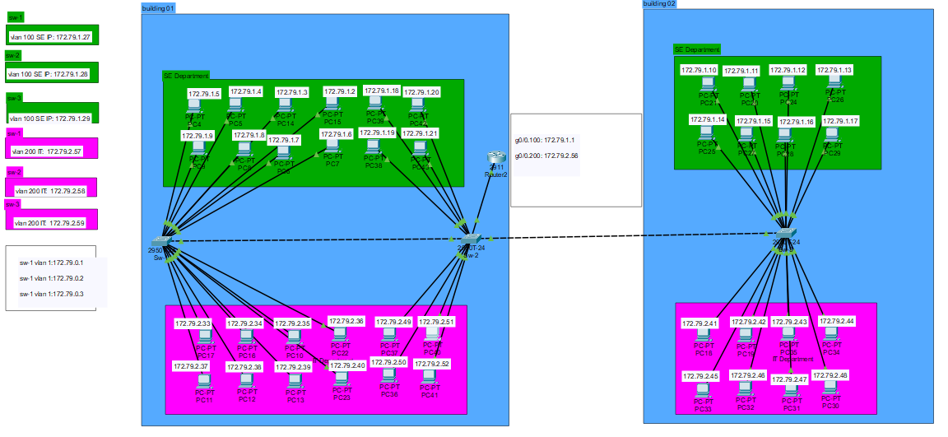

Step 1: Topology Design
Design the topology as shown in the figure.
  - Use Cisco Packet Tracer tocreate the topology.
  - Place a Router 2911 and three 2950T switches.
  - Use color coding to differentiate VLANs: VLAN 100 (e.g., green) and VLAN 200 (e.g., pink).
Step 2: VLAN Creation
- Access each switch and enter global configuration mode.
- Create VLAN 100 (SE) and VLAN 200 (IT):
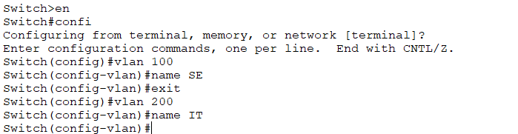
Dedicate 8 ports for each VLAN:
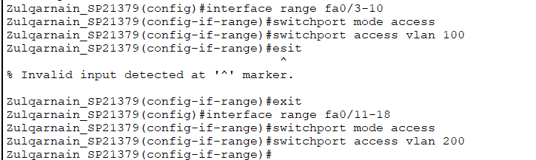
Configure trunk ports between switches and the router:
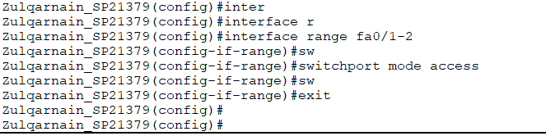

Step 3: Network Design
Computers can communication using all VLANs (VLAN1, VLAN 100 for SE and VLAN 200 for IT) are allowed in the network.
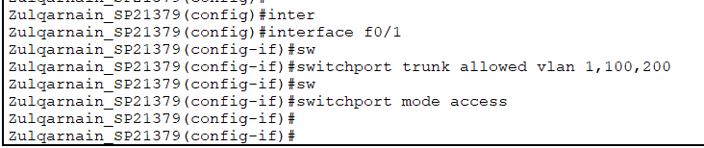

Inter-VLAN communication must be facilitated using a single router-on-a-stick configuration.
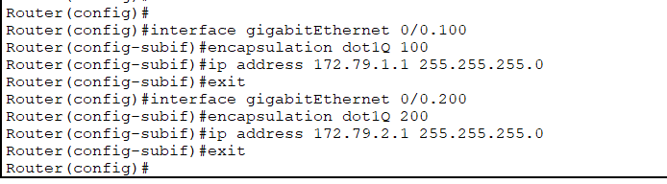
Native VLAN communication should be set to VLAN 100
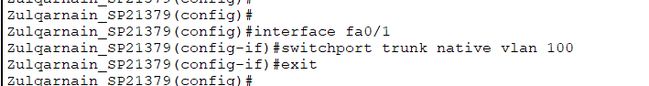

Step 4: IP Addressing
sub-netted Class B network (172.79.0.0/27)
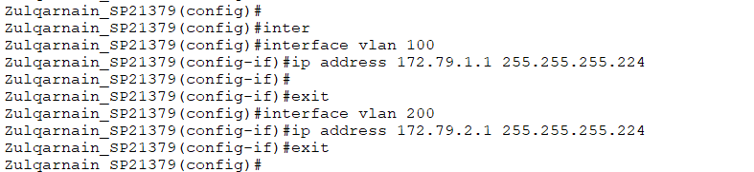

Step 5: Security Constraints:
  - Console and VTY access on switches and routers must be password.
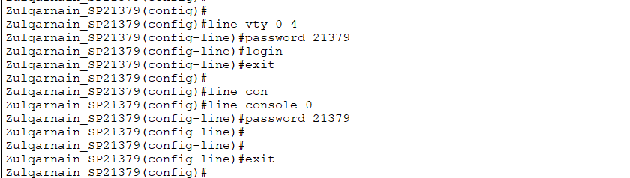
  - Privileged EXEC mode must require a password on all network devices.
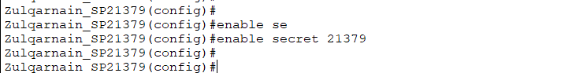

  - Give each Switch and a Router a MOTD of your own choice. Min 5, Max 10 Lines. Other than message it should show your Name, Roll No. and Department Name.
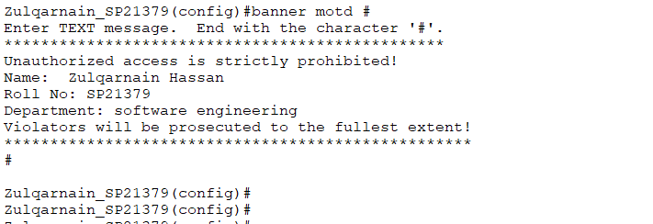

Network Communication
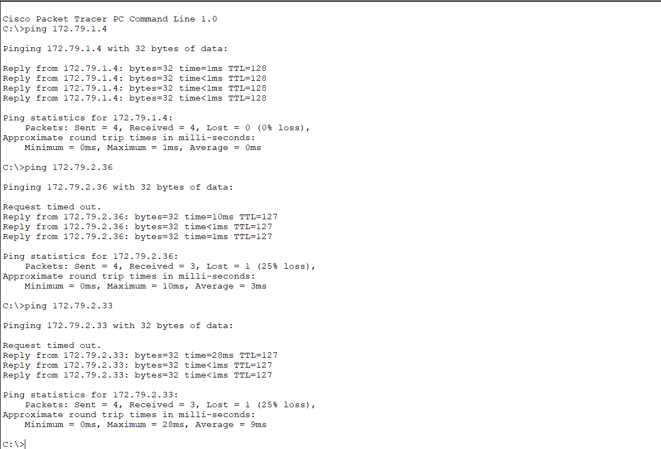
    - Pings to all VLANS.

    - Telnet from switch (sw-2 ) vlan 200 pc39 to neighbor switche (sw-10 vlan 100.
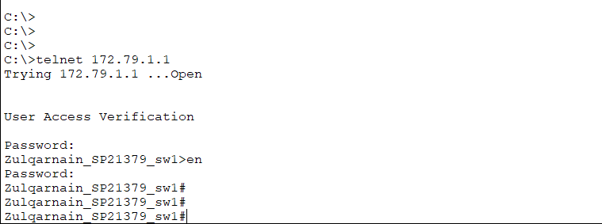
    - Pings to the designated VLAN’s Gateways.
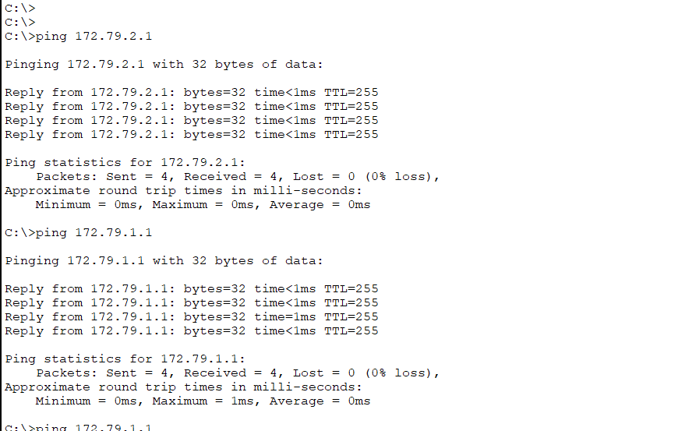

PC configurations
- Running configurations.
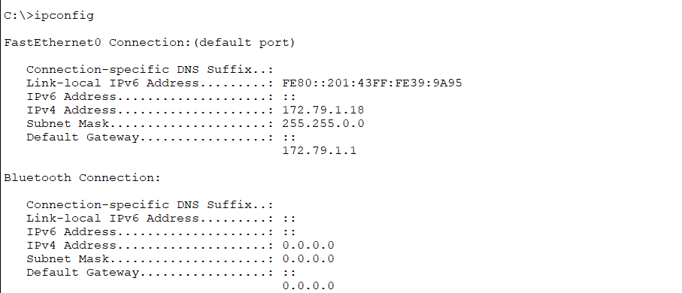
- VLAN briefs.
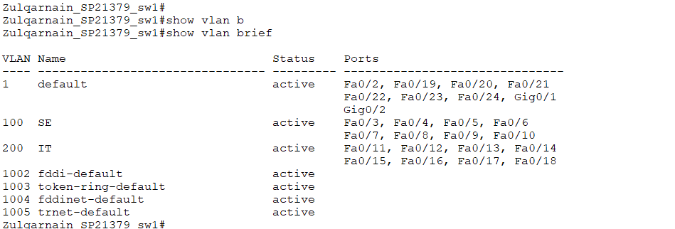
- Trunk information.
